**Report and Improve**

Recording information about incidents, complaints and feedback is a requirement under the NDIS.

Do you need to:

**Report an incident?**

**Lodge a complaint?**

**Give feedback?**

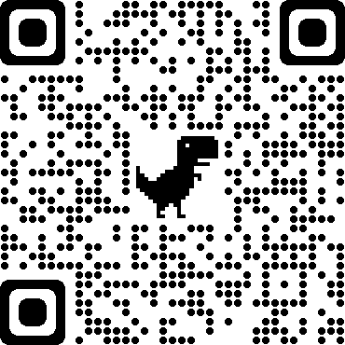

**It’s quick and easy**

**1**

Scan the QR code using your phone camera.

**2**

A link will pop up on your screen. Tap to open it.

**3**

Log in using your credentials (if you have not accessed the system recently).

**4**

Select the action you want to take.

**5**

Fill out all relevant details.

**6**

Click **Save.** This submits the information into the system.